Eastern Zone Community Health Plan Survey
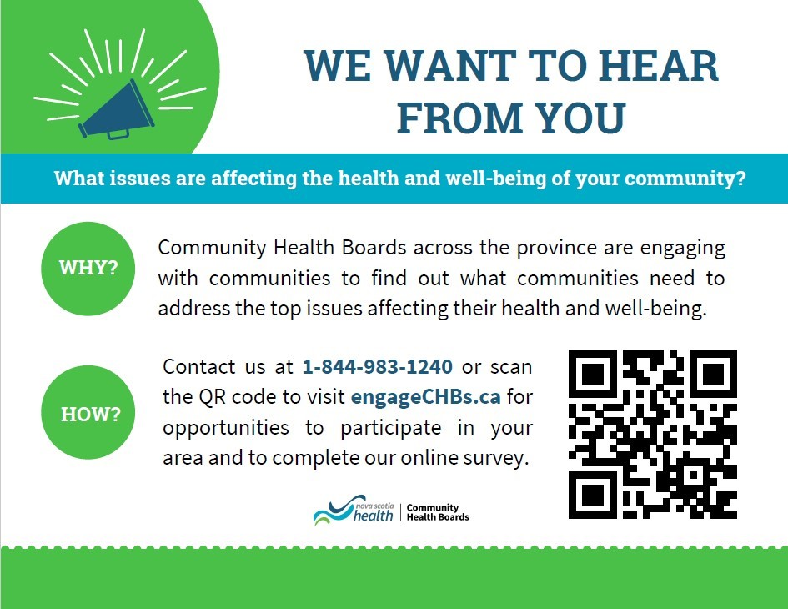

Have you heard?
The Eastern Zone Community Health Boards are creating a new Community Health Plan to guide their work for the next 5 years and we want to hear from you!
Please follow the link or scan the QR Code to access our survey.
Complete Survey Here
Or scan the attached QR Code Card

